Assignment 01

01

(a) Elaborate the following terms: OSI, DSl, TCP, FTP, DNS.

Ans: **OSI:**

OSI stands for **Open System Interconnection** is a reference model. The Open Systems Interconnection (OSI) model **describes seven layers that computer systems use to communicate over a network**. It was the first standard model for network communications, adopted by all major computer and telecommunication companies in the early 1980s.

* OSI consists of seven layers, and each layer performs a particular network function.

## Functions of the OSI Layers

There are the seven OSI layers. A list of seven layers are given below:

1. Physical Layer
2. Data-Link Layer
3. Network Layer
4. Transport Layer
5. Session Layer
6. Presentation Layer
7. Application Layer

DSL- Digital Subscriber Line

Digital Subscriber Line (DSL, *originally*, **digital subscriber loop**) is a communication medium, which is used to transfer internet through copper wire telecommunication line. Along with cable internet, DSL is one of the most popular ways *ISPs* provide broadband internet access. 

* Its aim is to maintain the high speed of the internet being transferred.
* If we ask that how we gonna achieve such a thing i.e., both telephone and internet facility, then the answer is by using *splitters or DSL filters*(shown in the below diagram). Basically, the use *splitter* is to splits the frequency and make sure that they can’t get interrupted

DSI:

The Dynamic Systems Initiative, or DSI, is a Microsoft and industry strategy intended to enhance the Windows platform, delivering a coordinated set of solutions that simplify and automate how businesses design, deploy, and operate their distributed systems. Using DSI helps IT and software developers create operationally aware platforms. By designing systems that are more manageable and automating operations, organizations can reduce costs and proactively address their priorities.

DSI is about building software that enables knowledge of an IT system to be created, modified, transferred, and operated on throughout the life cycle of that system. It is a commitment from Microsoft and its partners to help IT teams capture and use knowledge to design systems that are more manageable and to automate operations, which in turn reduces costs and gives organizations additional time to focus proactively on what is most important.

TCP:

* The TCP/IP model was developed prior to the OSI model.
* The TCP/IP model is not exactly similar to the OSI model.
* The TCP/IP model consists of five layers: the application layer, transport layer, network layer, data link layer and physical layer.
* The first four layers provide physical standards, network interface, internetworking, and transport functions that correspond to the first four layers of the OSI model and these four layers are represented in TCP/IP model by a single layer called the application layer.
* TCP/IP is a hierarchical protocol made up of interactive modules, and each of them provides specific functionality.

## Here, hierarchical means that each upper-layer protocol is supported by two or more lower-level protocols.

**Functions of TCP/IP layers:**

## 

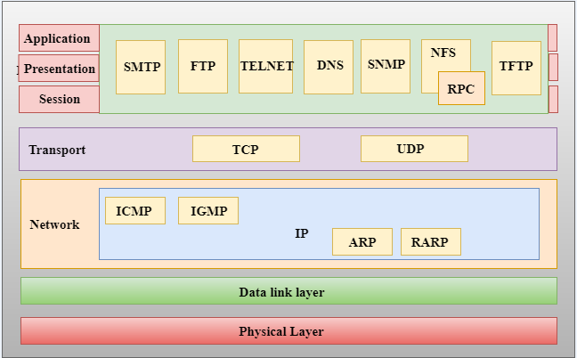

FTP: FTP stands for File transfer protocol. File transfer protocol is a way to download, upload, and transfer files from one location to another on the internet and between computer systems.

FTP is a standard internet protocol provided by TCP/IP used for transmitting the files from one host to another.

It is mainly used for transferring the web page files from their creator to the computer that acts as a server for other computers on the internet.

It is also used for downloading the files to computer from other servers.

File transfer protocol is one of many different protocols that dictate how computers and computing systems behave on the internet. Other such protocols include the:

* **Hypertext Transfer Protocol (HTTP):**Designed to transmit data across the web 4
* **Internet Message Access Protocol (IMAP):**Provides access to bulletin board or email messages from a shared service5
* **Network Time Protocol (NTP):** Synchronizes clock times on computers over a network.

## Objectives of FTP

* It provides the sharing of files.
* It is used to encourage the use of remote computers.
* It transfers the data more reliably and efficiently.

DNS: An application layer protocol defines how the application processes running on different systems, pass the messages to each other.

* DNS stands for Domain Name System.
* DNS is a directory service that provides a mapping between the name of a host on the network and its numerical address.
* DNS is required for the functioning of the internet.
* Each node in a tree has a domain name, and a full domain name is a sequence of symbols specified by dots.
* DNS is a service that translates the domain name into IP addresses. This allows the users of networks to utilize user-friendly names when looking for other hosts instead of remembering the IP addresses.
* For example, suppose the FTP site at EduSoft had an IP address of 132.147.165.50, most people would reach this site by specifying ftp.EduSoft.com. Therefore, the domain name is more reliable than IP address.

DNS is a TCP/IP protocol used on different platforms. The domain name space is divided into three different sections: generic domains, country domains, and inverse domain.

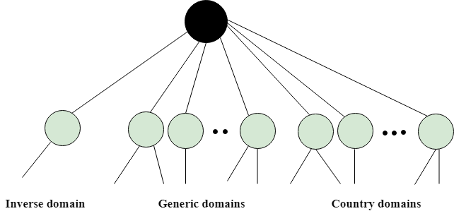

(b) Why did the OSI reference model fail?

Ans: One of the main reasons behind the failure of OSL model   and wider acceptance of  TCP/IP model  was because big global networks like internet started running on TCP/IP protocol suite.  All leading vendors discarded their proprietary networking protocols in favor of TCP/IP protocol suite.

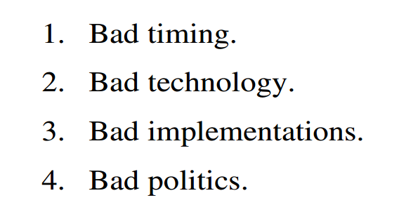

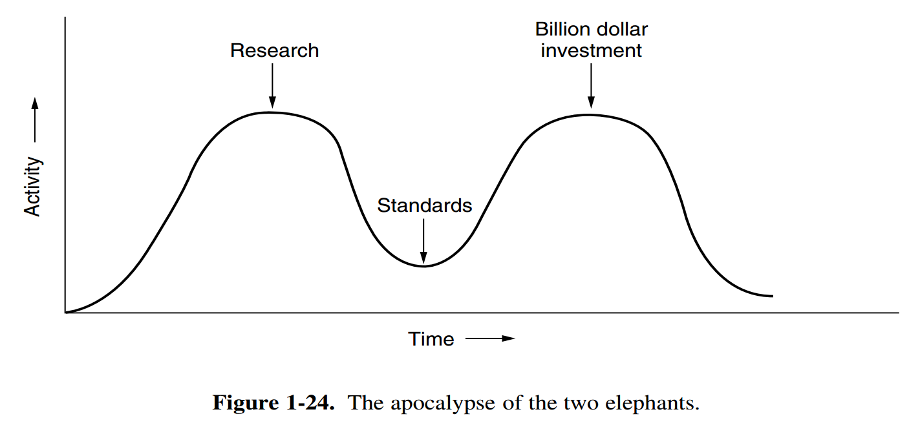

* **Bad Timing:**  
  In the OSI model, it is very essential and important to write standards in between trough i.e., apocalypse of two elephants. Time of standards is very critical as sometimes standards are written too early even before research is completed. Due to this, OSI model was not properly understood. The timing was considered bad because this model was finished and completed after huge and significant amount of research time. Due to this, the standards are ignored by these companies.
* **Bad Technology**

OSI models were never taken into consideration because of competition TCP/IP protocols that were already used widely. This is due to second reason that OSI model and its protocols are flawed that means both of them have fundamental weakness or imperfection or defect in character or performance or design, etc. The idea behind choosing all of seven layers of OSI model was based more on political issues rather than technical. Layers are more political than technical.

* **Bad Implementations**

The OSI model is extraordinarily and much more complex due to which initial implementations were very slow, huge, and unwidely. This is the third reason due to which OSI became synonymous with poor quality in early days. It turned out to not be essential and necessary for all of seven layers to be designed together to simply make things work out..

* **Bad Politics**

OSI model was not associated with UNIX. This was fourth reason because TCP/IP was largely and closely associated with Unix, which helps TCP/IP to get popular in academia whereas OSI did not have this association at that time.

(c) What is protocol? Can you explain the design issues of a usable protocol?

Ans: A protocol is a set of rules that governs the communications between computers on a network.

The design issues of a usable protocol:

**Reliability:**

* + uses codes for error detection.
  + error correction
  + They are used at low layers,

**Routing :**

* + Finding a working path through a network
  + addressing or naming,
  + internetworking.

**Resource allocation:**

* + Who will get priority
  + flow control.
  + Quality of service

**Confidentiality**

* + authentication
  + Integrity

(d) What do you know about ARPANET?

* Ans: **ARPANET**, in full **Advanced Research Projects Agency Network**, experimental  computer network that was the forerunner of the Internet.
* ARPA had no scientists or laboratories; in fact, it had nothing more than an **office and a small** (by Pentagon standards) **budget**.
* It did its work by issuing grants and contracts to **universities** and **companies** whose ideas looked promising to it.

**Characteristics of ARPANET:**

1. It is basically a type of WAN.
2. It used concept of Packet Switching Network.
3. It used Interface Message Processors (IMPs) for sub-netting.
4. ARPANETs software was split into two parts- a host and a subnet.

**Advantages of ARPANET :**

* ARPANET was designed to service even in a Nuclear Attack.
* It was used for collaborations through E-mails.
* It created an advancement in transfer of important files and data of defense.

**Limitations of ARPANET :**

* Increased number of LAN connections resulted in difficulty handling.
* It was unable to cope-up with advancement in technology.

02

(a)What is single mode and multimode fiber? Give us an comparison between them.

Ans:  **Single mode fiber**: a fiber featuring a small light-carrying core of about 9 micrometers

(µm) in diameter.  A single-mode optical fiber is a type of optical fiber that allows the propagation of only a single ray of light along the fiber. Here, the core to cladding diameter is 9 to 125 micrometres.

**Multimode fiber**: a fiber with a core of 50 µm or above.  A larger core means multiple modes (or rays of light) can travel down the core simultaneously. Another type of optical fiber is multimode optical fiber. In multimode optical fiber, several light rays propagate through the fiber at the same time, but, each reflects at a certain different angle than other during transmission.

The core to cladding diameter in case of multimode optical fiber is 50-62.5 to 125 micrometres

Single-Mode:  
- Small core diameter, 8 to 12 microns  
- Widely used cable in WAN networks today  
- More difficult and costly to terminate  
- Transmitters and receivers are more expensive  
- Typically used over long distances

Multi-Mode:

- Larger core diameter, usually 50 – 100 Micrometers, (62.5 most common)  
- Widely used cable in LAN networks today  
- Easier to terminate  
- Transmitters and receivers are more economical  
- Used at shorter distances



https://pixel.motusmedia.co/pixel?id=3158685

(b) What is GEO, MEO and LEO? What do you know about their altitude and minimum no of unit needed to cover the earth? The Bangabandhu -1 : our own satellite, what is its class?

### Four different types of satellites orbits have been identified. These are:

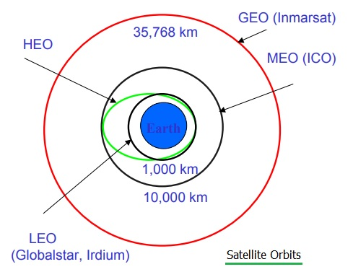

* **GEO (Geostationary Earth Orbit)** at about 36,000km above the earth's surface.
* **LEO (Low Earth Orbit)** at about 500-1500km above the earth's surface.
* **MEO (Medium Earth Orbit)** or **ICO (Intermediate Circular Orbit)** at about 6000-20,000 km above the earth's surface.
* **HEO (Highly Elliptical Orbit)**

## 1. GEO (Geostationary Earth Orbit)

* If a satellite should appear in fixed in the sky, it requires a period of 24 hours. Using the equation of distance earth and satellite, **r = (g.r2 /2.r.f)2)1/3** and the period of 24 hours **f = 1/24 h.** the resulting distance is **35,786 km.** the orbit must have an inclination of 0 degree.
* Geostationary satellites have a distance of almost 36,000 km to the earth. Examples are almost all TV and radio broadcast satellites, any weather satellites and satellites operating as backbones for the telephone network.

## 2. LEO (Low Earth Orbit)

* As LEOs circulate on a lower orbit, it is obvious that they exhibit a much shorter period (the typical duration of LEO periods are 95 to 120 minutes). Additionally, LEO systems try to ensure a high elevation for every spot on earth to provide a high quality communication link.
* Each LEO satellite will only be visible from the earth for about ten minutes.

## 3. MEO (Medium Earth Orbit)

## 3. MEO (Medium Earth Orbit)

* A MEO satellite situates in orbit somewhere between 6,000 km to 20,000 km above the earth's surface.
* MEO satellites are similar to LEO satellites in the context of functionality.

(c) GIVE US AN INSIGHT COMPARISON IN BETWWEN CIRCUIT SWITCHING AND PACKET SWITCHING.

|  |  |
| --- | --- |
| Difference between Circuit Switching and Packet Switching | |
| **Circuit Switching** | **Packet Switching** |
| A circuit needs to be established to make sure that data transmission takes place. | Each packet containing the information that needs to be processed goes through the dynamic route. |
| A uniform path is followed throughout the session. | There is no uniform path that is followed end to end through the session. |
| It is most ideal for voice communication, while also keeping the delay uniform. | It is used mainly for data transmission as the delay is not uniform. |
| Without a connection, it cannot exist, as the connection needs to be present on a physical layer. | A connection is not necessary, as it can exist without one too. It needs to be present on a network layer. |
| Data to be transmitted is processed at the source itself. | Data is processed and transmitted at the source as well as at each switching station. |

(d) Give us a brief description about the devices used in X.25 protocol.

**X.25** is an ITU-T standard protocol suite for packet-switched  data communication in wide area networks  (WAN). This protocol is also known as Subscriber Network Interface (SNI) Protocol. It is a packet-switched network technology that is used long before ago. It basically allows all of the remote devices to communicate with each other across the high-speed digital links with no expense of individual leased lines. X.25 was basically developed for computer connections that are used for terminal or timesharing connection.

X.25 network devices generally fall into different categories as given below:

1. **Data Terminal Equipment (DTE):**  
   DTE is basically an instrument or equipment that acts as a source or destination in digital communication and is used to convert user information or data into signals and then also reconverts all received signals into user information. These are basically the end systems that are used to communicate across the X.25 network.
2. **Data Circuit-Terminating Equipment (DCE):**  
   DCE is sometimes also known as data communication equipment and data carrier equipment. It is a device that is fitted between the DTE and Data transmission circuit. All the communications details regarding sending and receiving data are left to the DCE.

It is generally a signal conversion device that converts signals from DTE to another form that is more suitable to be transported over a transmission channel.

1. **Packet Switching Exchange (PSE):**  
   PSE is basically the switches that compose the bulk of the carrier’s network and are located in the carrier’s facilities. PSE is synchronous i.e., there is a clocking circuit that controls the timing of communication among the routers. These PSEs are also PADs, and even they disassemble and reassemble the packets.

03

(a)What is collision? Can you explain the slotted aloha protocol scheme.

A collision is **the result of two devices on the same Ethernet network attempting to transmit data at exactly the same time**.

Slotted aloha protocol scheme:

In this, any station can transmit the data at the beginning of any time slot.

The time is discrete and globally synchronized. Vulnerable time for Slotted aloha = Tt.In Slotted Aloha, Probability of successful transmission of data packet= G x e-G

In slotted aloha, Maximum efficiency = 36.8%

Slotted aloha reduces the number of collisions to half and doubles the efficiency of pure aloha.

(b) Explain the BIT-MAP protocol as a collision free protocol.

Bit-map protocol is a collision free protocol that operates in the Medium Access Control (MAC) layer of the OSI model. It resolves any possibility of collisions while multiple stations are contending for acquiring a shared channel for transmission. 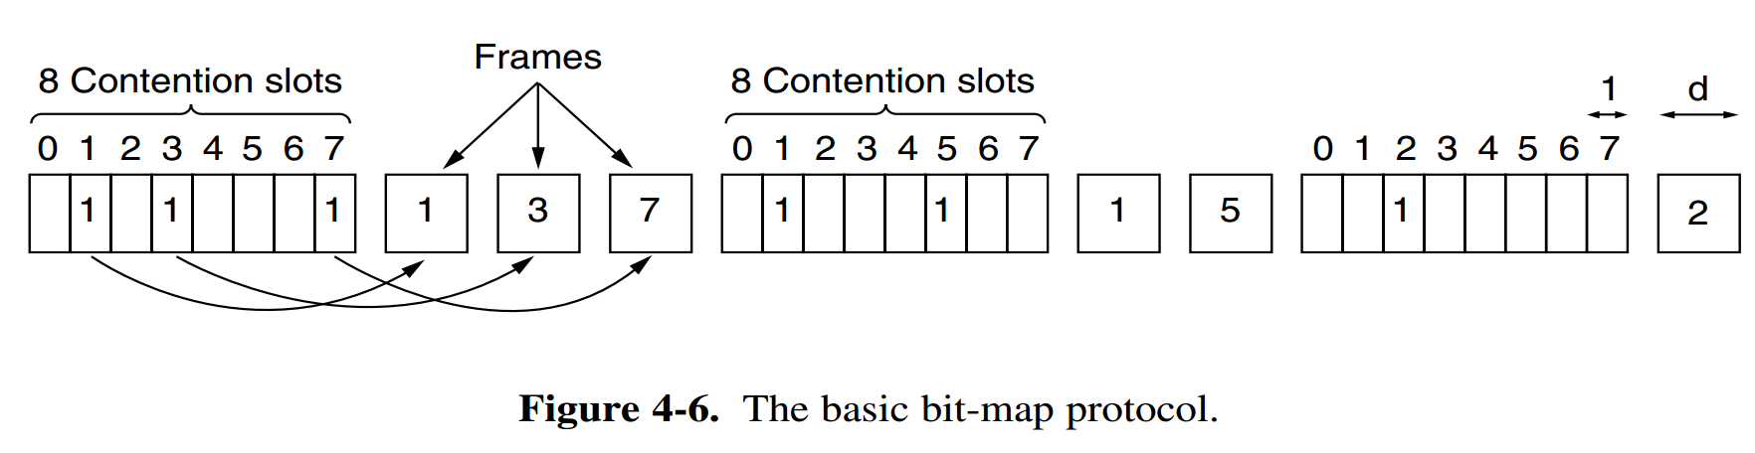

(c) Give us an idea about the difference in between switch and hub.

**Difference between Hub and Switch:** 

|  |  |  |
| --- | --- | --- |
| S.NO | HUB | SWITCH |
| 1. | Hub is operated on **Physical layer of OSI model**. | While switch is operated on **Data link layer of OSI Model**. |
| 2. | Hub is a broadcast type transmission. | While switch is a Unicast, multicast and broadcast type transmission. |
| 3. | Hub have 4/12 ports. | While switch can have 24 to 48 ports. |
| 4. | In hub, there is only one collision domain. | While in switch, different ports have own collision domain. |
| 5. | Hub is a half duplex transmission mode. | While switch is a full duplex transmission mode. |
| 6. | In hub, Packet filtering is not provided. | While in switch, Packet filtering is provided. |
| 7. | Hub cannot be used as a repeater. | While switch can be used as a repeater. |
| 8. | Hub is not an intelligent device that sends message to all ports hence it is comparatively inexpensive. | While switch is an intelligent device that sends message to selected destination so it is expensive. |
| 9. | Hub is simply old type of device and is not generally used. | While switch is very sophisticated device and widely used. |
| 10. | Hacking of systems attached to hub is complex. | Hacking of systems attached to switch is little easy. |

(d) What is framing? How byte count mechanism is used in data link layer framing?

Framing: Framing is a point-to-point connection between two computers or devices consists of a wire in which data is transmitted as a stream of bits. Framing is a function of the data link layer. It provides a way for a sender to transmit a set of bits that are meaningful to the receiver.

The byte count framing method uses a field in the header to specify the number of bytes in the frame.

1. Data link layer at sender sends the byte count.
2. Data link layer at receiver counts the byte count. send by sender.
3. If there is difference between  bytes counts of sender and receiver. There is error in data received.
4. Else received data is correct.
5. Above points are shown in diagram below.

[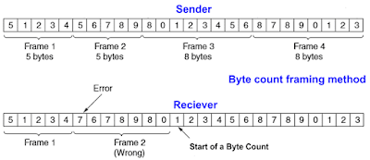](https://1.bp.blogspot.com/-gqKoE377Zhw/XtveMR0uyOI/AAAAAAAAGA8/LdY6sL8nSJwWDM_tclxmkNn23wDpMFVAgCK4BGAsYHg/s840/Bytr%2Bcount%2Bframing%2Bmethod.png)

Assignment 02

1.How can we identify the class of a given IPv4 address?

Classes of IPv4

1. Class A: If it begins with 0, then it's a Class A network
2. Class B: it begins with 10, then it's a Class B network.
3. Class C: If it begins with 110, then it's a Class C network.

4.Class D: If it begins with 1110, then it's a Class D network.

5. Class E: If it begins with 1111, then it's a Class E network.

2. What is “variable length Subnet Masks”?

Variable Length Subnet Mask (**VLSM**) is a subnet -- a segmented piece of a larger network -- design strategy where all subnet masks can have varying sizes.

3.Write a short note on Flooding routing technique.

Flooding is a non-adaptive routing technique following this simple method: when a data packet arrives at a router, it is sent to all the outgoing links except the one it has arrived on.

For example, let us consider the network in the figure, having six routers that are connected through transmission lines.

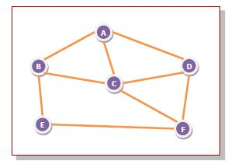

Using flooding technique −

* An incoming packet to A, will be sent to B, C and D.
* B will send the packet to C and E.
* C will send the packet to B, D and F.
* D will send the packet to C and F.
* E will send the packet to F.
* F will send the packet to C and E.

## types of Flooding

Flooding may be of three types −

* **Uncontrolled flooding**
* **Controlled flooding**
* **Selective flooding**

1. What is known as the optimality principle?

Ans: One can make a general statement about optimal routes without regard to network topology or traffic. This statement is known as the optimality principle. It states that **if router J is on the optimal path from router I to router K, then the optimal path from J to K also falls along the same route.**

#### ****Statement of****the ****optimality principle**** :

It states that if the router J is on the optimal path from router I to router K, then the optimal path from J to K also falls along the same route.  Call the route from I to J *r1* and the rest of the route*r2*. it could be concatenated with*r1* to improve the route from I to K, contradicting our statement that*r1r2* is optimal only if a route better than r2 existed from J to K.

1. What is meant by connection oriented and connection less communication?

Connection oriented communication: It is used to create an end to end connection between the senders to the receiver before transmitting the data over the same or different network. Connection-oriented service involves the creation and termination of the connection for sending the data between two or more devices.

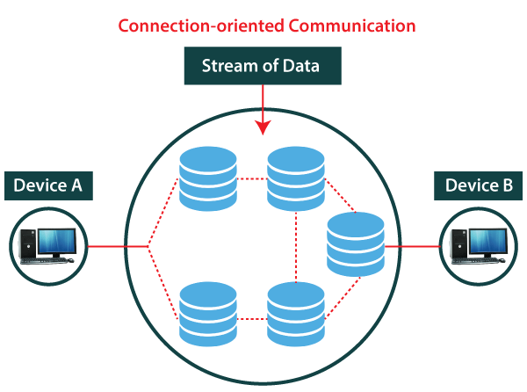

Connection less communication: It is used to transfer the data packets between senders to the receiver without creating any connection. Connectionless service is used in the network system to transfer data from one end to another end without creating any connection.

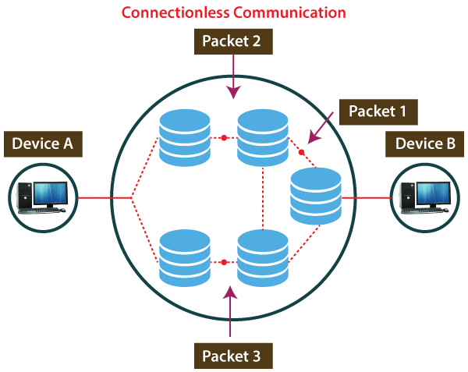

1. Why is the mechanism of releasing TCP connection made such complex instead of just releasing connection?

7. What is BOOTP? Can you differentiate the operation between BOOTP and DHCP?

**Ans: BOOTP** (Bootstrap Protocol) is an internet protocol that lets a network user automatically be configured to receive an IP address and have an operating. BOOTP is a TCP/IP protocol. It **allows a client to find its IP address and the name of a load file from a server on the network**.

Following are the important differences between BOOTP and DHCP.

|  |  |  |
| --- | --- | --- |
| 1. | BOOTP stands for Bootstrap Protocol. | While DHCP stands for Dynamic host configuration protocol. |
| 2. | BOOTP does not provide temporary IP addressing. | While DHCP provides temporary IP addressing for only limited amount of time. |
| 3. | BOOTP does not support DHCP clients. | While it support BOOTP clients. |
| 4. | In BOOTP, manual-configuration takes place. | While in DHCP, auto-configuration takes place. |
| 5. | BOOTP does not support mobile machines. | Whereas DHCP supports mobile machines. |
| 6. | BOOTP can have errors due to manual-configuration. | Whereas in DHCP errors do not occur mostly due to auto-configuration. |

8. Explain how the differential pulse code modulation encoding technique works.

Differential pulse code modulation is a technique of analog[to digital signal conversion](https://www.elprocus.com/analog-to-digital-adc-converter/). This technique samples the analog signal and then quantizes the difference between the sampled value and its predicted value, then encodes the signal to form a digital value.

If the input is a [continuous-time](https://en.wikipedia.org/wiki/Continuous-time) analog signal, it needs to be [sampled](https://en.wikipedia.org/wiki/Sampling_(signal_processing)) first so that a [discrete-time signal](https://en.wikipedia.org/wiki/Discrete-time_signal) is the input to the DPCM encoder.

* Option 1: take the values of two consecutive samples; if they are analog samples, [quantize](https://en.wikipedia.org/wiki/Quantization_(signal_processing)) them; calculate the difference between the first one and the next; the output is the difference.
* Option 2: instead of taking a difference relative to a previous input sample, take the difference relative to the output of a local model of the decoder process; in this option, the difference can be quantized, which allows a good way to incorporate a controlled loss in the encoding.

1. What do you think about the reasons for the failure of the OSI reference model?

( same as 1(b))

10. Have you heard then term ARPANET? What is it?

( same as 1(d))